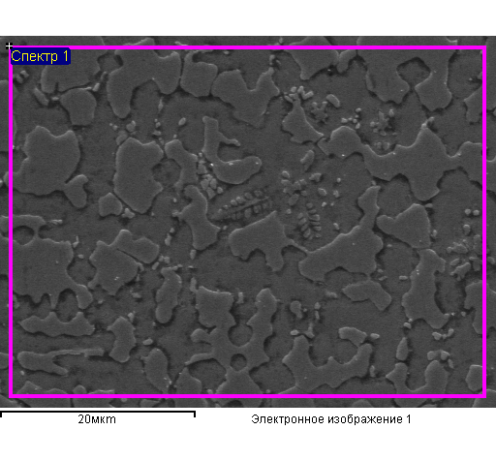

Total composition of marked area Structure element 1

|  |  |  |  |  |  |  |
| --- | --- | --- | --- | --- | --- | --- |
| Element | Mass. % | Atomic% |  | Element | Mass. % | Atomic% |
| Ti K | 57.95 | 61.64 |  | Ti K | 47.37 | 51.21 |
| Fe K | 42.05 | 38.36 |  | Fe K | 52.63 | 48.79 |
| Total | 100.00 |  |  | Total | 100.00 |  |

Structure element 2 Structure element 3

|  |  |  |  |  |  |  |
| --- | --- | --- | --- | --- | --- | --- |
| Element | Mass. % | Atomic% |  | Element | Mass. % | Atomic% |
| Ti K | 62.83 | 66.34 |  | N K | 5.74 | 17.63 |
| Fe K | 37.17 | 33.66 |  | Ti K | 76.60 | 68.78 |
| Total | 100.00 |  |  | Fe K | 17.66 | 13.60 |
|  |  |  |  | Total | 100.00 |  |

Structure element 3

|  |  |  |
| --- | --- | --- |
| Element | Mass. % | Atomic% |
| N K | 5.74 | 17.50 |
| Ti K | 82.19 | 73.27 |
| Fe K | 12.07 | 9.23 |
| Total | 100.00 |  |

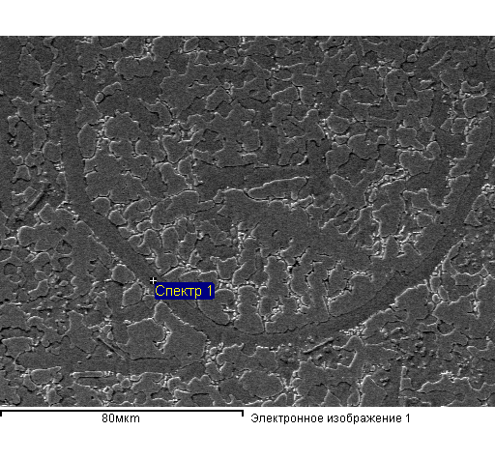

Structure element 4 Structure element 5

|  |  |  |  |  |  |  |
| --- | --- | --- | --- | --- | --- | --- |
| Element | Mass. % | Atomic% |  | Element | Mass. % | Atomic% |
| Ti K | 58.53 | 62.20 |  | Ti K | 47.64 | 51.48 |
| Fe K | 41.47 | 37.80 |  | Fe K | 52.36 | 48.52 |
| Total | 100.00 |  |  | Total | 100.00 |  |

Structure element 6 Structure element 7

|  |  |  |  |  |  |  |
| --- | --- | --- | --- | --- | --- | --- |
| Element | Mass. % | Atomic% |  | Element | Mass. % | Atomic% |
| Ti K | 57.78 | 61.48 |  | Ti K | 58.16 | 61.84 |
| Fe K | 42.22 | 38.52 |  | Fe K | 41.84 | 38.16 |
| Total | 100.00 |  |  | Total | 100.00 |  |

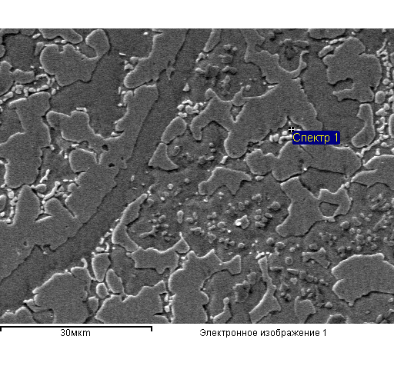

Structure element 8 Structure element 9

|  |  |  |  |  |  |  |
| --- | --- | --- | --- | --- | --- | --- |
| Element | Mass. % | Atomic% |  | Element | Mass. % | Atomic% |
| Ti K | 52.34 | 56.15 |  | N K | 7.74 | 22.64 |
| Fe K | 47.66 | 43.85 |  | Ti K | 79.24 | 67.80 |
| Total | 100.00 |  |  | Fe K | 13.02 | 9.56 |
|  |  |  |  | Total | 100.00 |  |

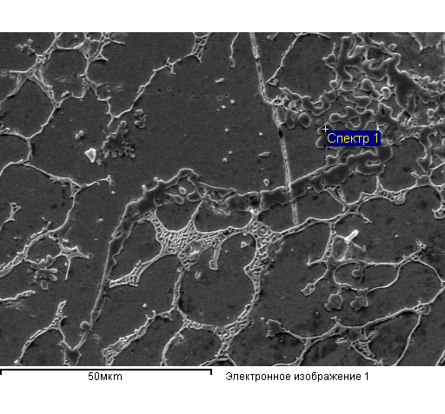

Structure element 9 Structure element 10

|  |  |  |  |  |  |  |
| --- | --- | --- | --- | --- | --- | --- |
| Element | Mass. % | Atomic% |  | Element | Mass. % | Atomic% |
| N K | 6.60 | 14.14 |  | N K | 7.21 | 15.45 |
| O K | 21.98 | 41.20 |  | O K | 21.27 | 39.89 |
| Ti K | 70.63 | 44.23 |  | Ti K | 69.90 | 43.79 |
| Fe K | 0.79 | 0.42 |  | Fe K | 1.62 | 0.87 |
| Total | 100.00 |  |  | Total | 100.00 |  |

Structure element 11 Structure element 12

|  |  |  |  |  |  |  |
| --- | --- | --- | --- | --- | --- | --- |
| Element | Mass. % | Atomic% |  | Element | Mass. % | Atomic% |
| Ti K | 28.18 | 31.39 |  | C K | 2.61 | 10.91 |
| Fe K | 71.82 | 68.61 |  | Ti K | 10.50 | 11.01 |
| Total | 100.00 |  |  | Fe K | 86.88 | 78.09 |
|  |  |  |  | Total | 100.00 |  |

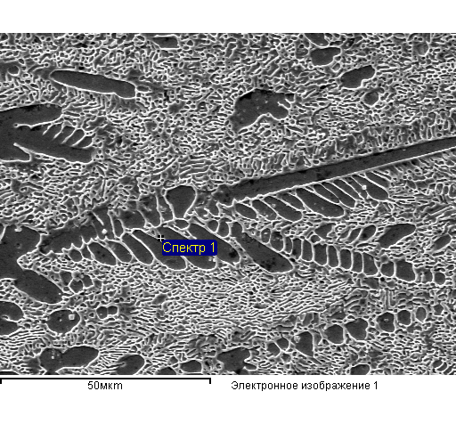

Structure element 13 Structure element 14

|  |  |  |  |  |  |  |
| --- | --- | --- | --- | --- | --- | --- |
| Element | Mass. % | Atomic% |  | Element | Mass. % | Atomic% |
| C K | 3.41 | 13.96 |  | C K | 3.85 | 15.13 |
| Ti K | 7.15 | 7.34 |  | Ti K | 25.25 | 24.90 |
| Fe K | 89.44 | 78.70 |  | Fe K | 70.90 | 59.96 |
| Total | 100.00 |  |  | Total | 100.00 |  |

Structure element 15

|  |  |  |
| --- | --- | --- |
| Element | Mass. % | Atomic% |
| C K | 2.87 | 11.89 |
| Ti K | 11.42 | 11.84 |
| Fe K | 85.71 | 76.26 |
| Total | 100.00 |  |

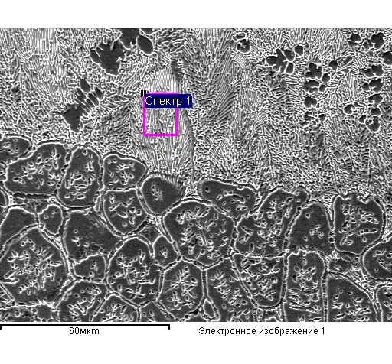

Structure element 16 Structure element 17

|  |  |  |  |  |  |  |
| --- | --- | --- | --- | --- | --- | --- |
| Element | Mass. % | Atomic% |  | Element | Mass. % | Atomic% |
| C K | 2.25 | 9.52 |  | Ti K | 24.42 | 27.36 |
| Ti K | 11.60 | 12.27 |  | Fe K | 75.58 | 72.64 |
| Fe K | 86.15 | 78.21 |  | Total | 100.00 |  |
| Total | 100.00 |  |  |  |  |  |

Structure element 18 Structure element 19

|  |  |  |  |  |  |  |
| --- | --- | --- | --- | --- | --- | --- |
| Element | Mass. % | Atomic% |  | Element | Mass. % | Atomic% |
| C K | 3.83 | 15.53 |  | C K | 4.10 | 16.47 |
| Ti K | 4.16 | 4.23 |  | Ti K | 4.08 | 4.11 |
| Fe K | 92.01 | 80.24 |  | Fe K | 91.83 | 79.42 |
| Total | 100.00 |  |  | Total | 100.00 |  |